**Mission 6:**

**Heartbeat**

**Student Workbook**



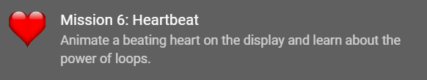

**Let’s keep it going**

Your programs are cool, but they only run one time. Then they stop. Let’s keep the code going by repeating the code in a loop. Also, you will use buttons to control the code.

You have probably seen flashing traffic road signs or traffic lights.

Go to the Mission 6 Log and fill out the   
Pre-Mission preparation.

* Make a list of blinking indicators (like flashing traffic road signs)



**Mission 6: Heartbeat**

**In this project you'll give the CodeX a *beating heart.***

Okay, not a *real* heart - that would be a little too messy!

**But** using the display you can give the CodeX its own *digital* heart, and even make it speed up and slow down just like your own heart does.

**Mission 6: Get started**

* Go to <https://make.firialabs.com/> and log in.



* Go to Mission 6



* Click and start Mission 6.

**Objective #1: Lots of heart**

Start by reviewing programming concepts from your earlier missions.

Show a heart image on the screen.

* You might recognize this as the same code as your first project.
* Don't worry, you're going to add a *lot* of new features soon!

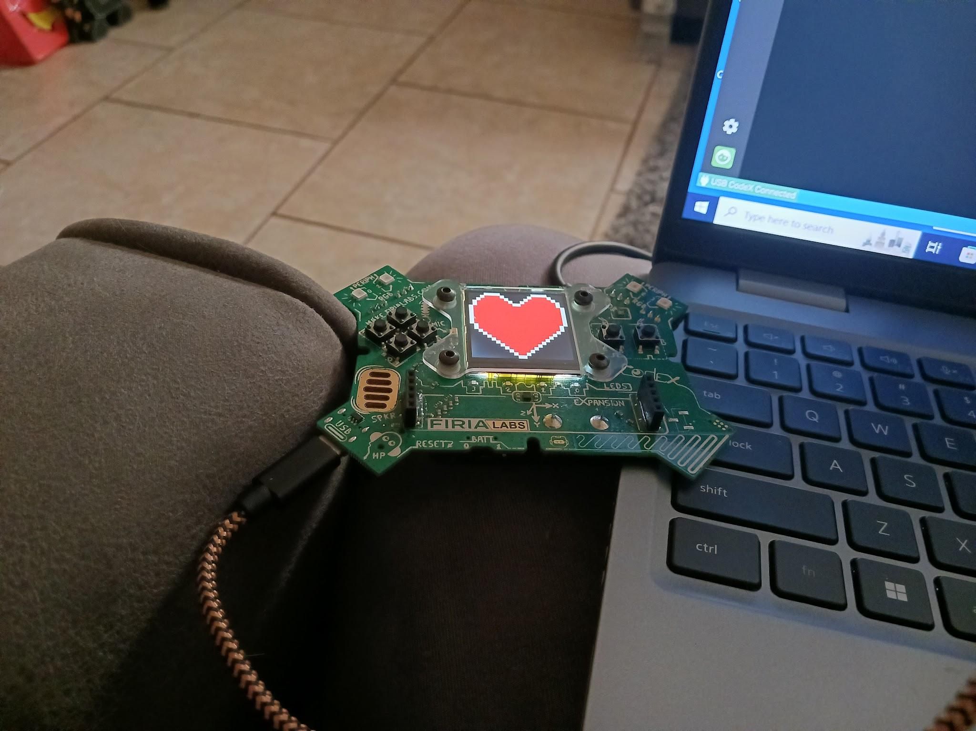

**Objective #1: Lots of heart**

**DO THIS:**

* Start a new file named **Heart2**
* Show pics.HEART on the CodeX display
  + Use CodeTrek if you need help

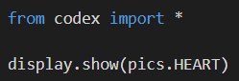



**Objective #2: Pump it UP**

Now you will animate the heart to make it look like it is beating.

* You will need two heart images:
  + **pics.HEART**
  + **pics.HEART_SMALL**
* You need a **delay** variable to see both images
* You need to **import sleep** to use the **delay** variable





**DO THIS:**

* From time, import sleep
* Define a delay variable
* Show the first heart
  + Then sleep
* 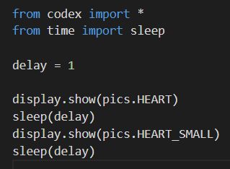Show the second heart
  + Then sleep

**Objective #3: Repeat da beat**

Now you have a heartbeat.

But one heartbeat isn’t an animation.

* You can repeat the code to repeat the heartbeat several times





**DO THIS:**

* Repeat the code for the large and small hearts   
   at least **4** times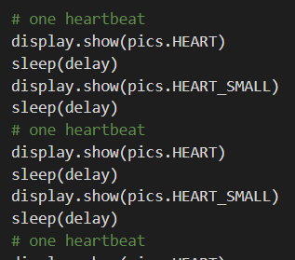

**Objective #4: Hearts forever**

Four beats is a good animation, but it ends.

We want our heart animation to run forever.

* You can’t just copy millions of times
* Instead, tell the computer to repeat the code
* Repeating code without retyping is called a LOOP



**DO THIS:**

* Click on
* Go to your Mission Log and answer the questions for Objective #4
* Click on 
* 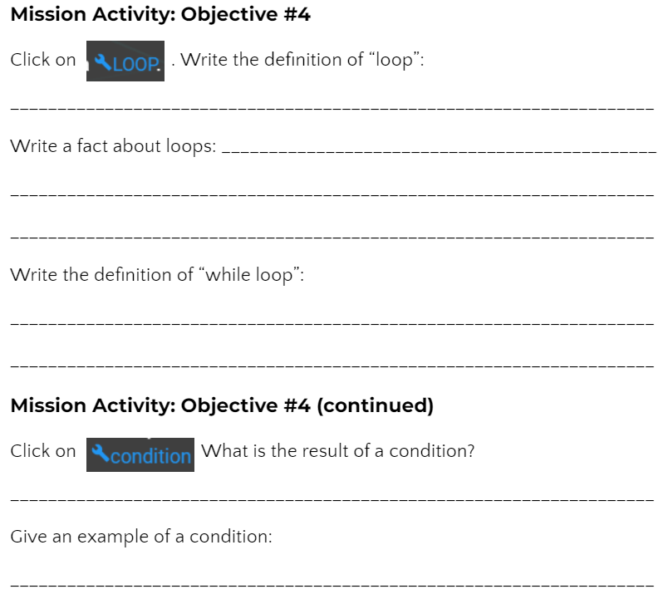Go to your Mission Log and answer the questions for Objective #4

**Objective #4: Hearts forever**

Modify your code

**DO THIS:**

* Delete all the repeated code except the first heartbeat
* Add a while loop to the code
  + Type a colon (:) at the end of the line
  + Indent the heartbeat code
  + Use the TAB key to indent your heartbeat code
* Run the code
  + You will need to click “STOP RUNNING” to end the code.

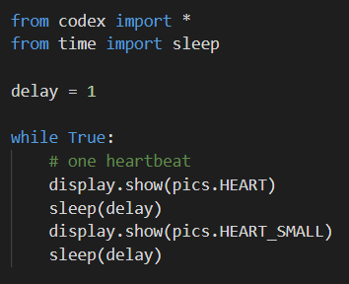

**Objective #5: Stop it!**

A while loop that goes forever without stopping is an **infinite loop**. This is because the condition is always True.

* Right now, the only way to stop the loop is to click the “**STOP**” button

The heartbeat changes at the same speed, forever.

* You can change the value of **delay** to change the speed of the heartbeat

**DO THIS:**

* Go to your Mission Log and write the definition for **infinite loop**.

Modify your code

* If your code is still running, click “STOP”
* 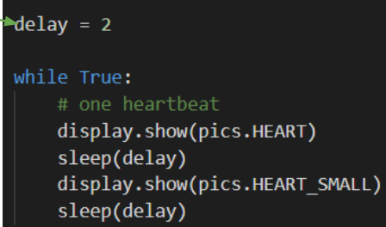Change the value of **delay** to 2
* Run the code
* Click “STOP”
* Change the value of **delay**   
  to 0.5
* Run the code
* Click “STOP”
* OPTIONAL: try different values for **delay**

**Objective #6: Heart break**

You still have an infinite loop.

* Instead of clicking the “STOP” button, write code to stop the loop
* Use a **break** command
* The **break** command is used in an **if** statement
* Press a button to break out of the loop and stop the program

**DO THIS:**

* Click on
* Go to your Mission Log and answer the questions for Objective #6

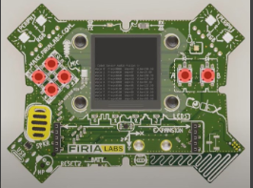

**Objective #6: Heart break**

Modify your code

**DO THIS:**

* Add an if statement to the while loop to   
   break out of the loop
  + Be careful with the indenting
  + Make sure to add a colon (:) after the if statement
* Run the code
* Press the “A” button to stop   
  the code

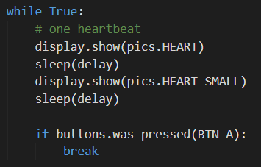

**Objective #7: Explore the beat**

Now your CodeX is interactive!

And your coding skills are growing.

* You learned about
  + Input -- using a button press
  + Branching -- if statements with a condition
* Now you CodeX can do something different when a button is pressed

**Review the concepts**

* Branching
  + Use an if statement
  + Has a condition
  + The condition can be True or False
  + If the condition is True, the indented code is executed
  + If the condition is False, the indented code is skipped

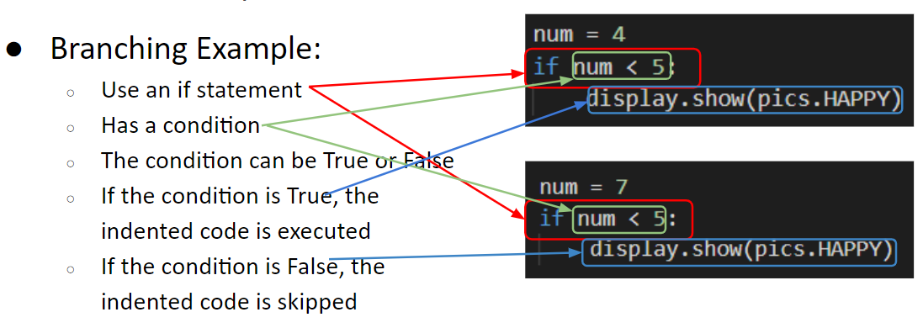

**Objective #7: Explore the beat**

**Review the concepts**

* CodeX button input
  + Two different functions check for a CodeX button press
  + **buttons.was_pressed(BTN_A)**
    - Checks to see if BTN_A was pressed since the last check
  + **buttons.is_pressed(BTN_A)**
    - Checks to see if BTN_A is currently pressed
  + Both functions are a condition
    - * They evaluate to True or False
  + Both functions can be used in an if statement

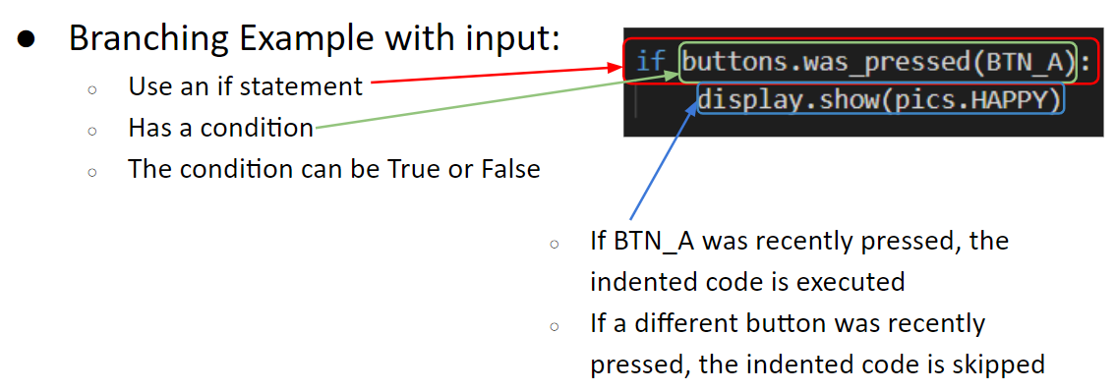

**Objective #7: Explore the beat**

Experiment with the code 

**DO THIS:**

* Click the debugger button
* Use the Step Over button to watch the branching
* You must step at least 8 times
* Go through the while loop one time
* Then press BTN_A and go through the loop again
* The code should break out of the loop and stop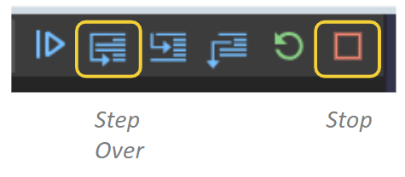

 **Mission Quiz: Break-fast**

Test your skills by **taking the quiz**.

**Objective #8: Half a sleep**

You can make the heart beat faster!

What controls the speed of the beat so far?

* The **delay** variable in sleep()

To beat faster, the **delay** variable needs to be a smaller value.

But what is smaller than delay = 1?

* There isn’t an integer less than 1 that can be used for delay
* You need to use a real number, or decimal, like 0.5 or 0.75
* The decimal in the number is called a “floating point”
* The data type for a real number is **float**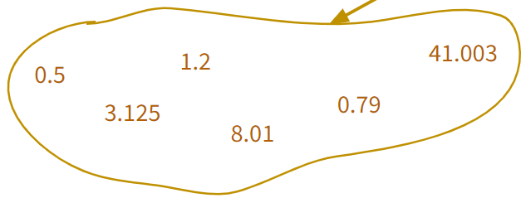

**Objective #8: Half a sleep**

Now you know five data types:

* Integer (Examples: 1, 54, 720)
* CodeX image (Examples: pics.HEART, pics.MUSIC)
* String (Examples: “Hello”, “Press A”, “cake”)
* Boolean (Values: True, False)
* Float (Examples: 0.5, 3.125, 49.02)



**DO THIS:**

* Set the value of delay to 1
* Use the float value 0.5 in the two sleep() commands
* Run the code
* After a few fast heartbeats, press BTN_A to stop the program

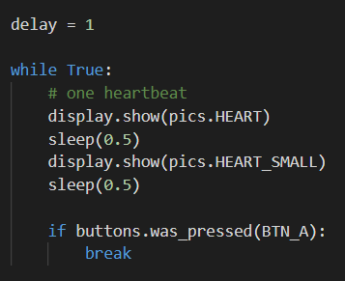

**Objective #9: Variable speed control**

You can change the speed of the heartbeat by changing the value of the variable **delay**.

* You will need your **delay** variable
* You will need to use it in the **sleep()** command



**DO THIS:**

* Use the delay variable in the 2 sleep() commands
* Run the code
* After a few fast heartbeats, press BTN_A to stop the program

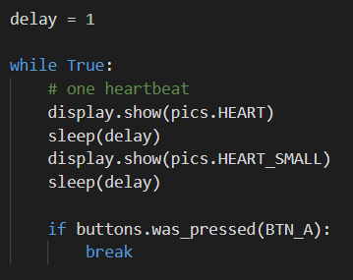

**Objective #10: Brake! Not break**

With a variable, your heartbeat speed is easy to change.

* You can change the speed while the program is running
* Use the buttons to change the value of delay

Look at the code below:



Look carefully at the indented code:

* This doesn’t make sense in math, but it does make sense to a computer
* The original value of **delay** is 1, or 1.0
* Then 0.2 is added to the current value
* The new value is assigned to **delay**, like this:

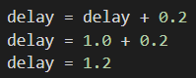

**Objective #10: Brake! Not break**

* Adding a set amount, like 0.2, to a variable is called “**increment**”
* In this code, every time BTN_A is pressed, the delay will increase by 0.2
* A larger number for delay will slow down the heartbeat



Ready to try? Your first goal is to slow down the heartbeat.

**DO THIS:**

* Change the if statement
* Remove “break”
* Replace it by incrementing delay
* Run the code and press BTN_A a few times
* The heartbeat should slow down each time
* 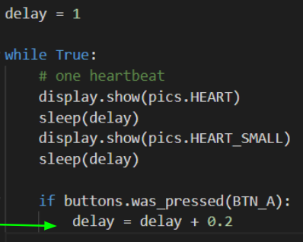Press the STOP button to stop the program

**Objective #11: Variable speed heart**

You added code to slow down the heartbeat. Now add code to speed up the heartbeat.

* Use BTN_B
* The code will be almost the same as the if statement for BTN_A

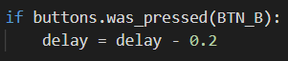

Look carefully at the indented code:



* The original value of **delay** could be 1.0, or 1.2, or 1.4
* In this code, 0.2 is subtracted from the current value
* Then the new value is assigned to **delay**, like this:

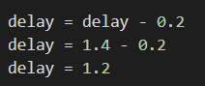

**Objective #11: Variable speed heart**



* Subtracting a set amount, like 0.2, to a variable is called “**decrement**”
* In this code, every time BTN_B is pressed, the delay will decrease by 0.2
* A smaller number for delay will speed up the heartbeat

When you add the if statement, you can speed up and slow down the heartbeat with the press of two buttons

* But … be careful!
* Pressing BTN_B several times can give a 0 or negative value for delay
* The sleep() function must have a positive value!
* So, an error will occur if BTN_B is pressed too many times.

**Objective #11: Variable speed heart**



**DO THIS:**

* Go to your Mission Log and complete the questions for Objective #10 and Objective #11

Complete the second goal to speed up the heartbeat.

* Add an if statement for BTN_B to decrement delay
* Run the code and press BTN_A a few times and BTN_B a few times
* The heartbeat should slow down and speed up
* 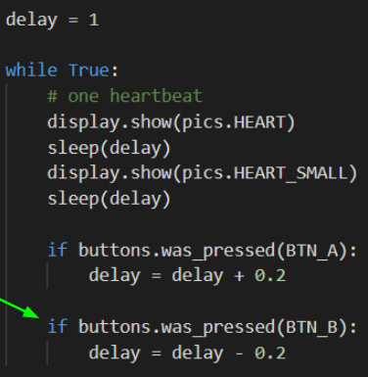Press BTN_B enough times to cause an error and stop the program

**Mission Quiz: Heartfelt Recap**

Test your skills by **taking the quiz**.

**Mission Complete**

You have completed the sixth mission. 

**Do this:**

* Read your “Completed Mission” message
* Complete your Mission 6 Log
  + Post-Mission Reflection
* Get ready for your next mission!

**Wait! Before you go … Clear the CodeX**

Go to FILE -- BROWSE FILES

Select the “**Clear**” file and open it

Run the program to clear the CodeX

**Okay. Now you can go.**